## **SCCM CLIENT**

## **Pre-requisites:**

* SCCM CLIENT archive file ' SCCM_CLIENT.zip' setup file must be downloaded from below steps-

a. SCCM Server must be installed

b. Note: SSCMSetup.exe and the supporting files are on the site server in the Clinet folder of the Configuration Mangar installation folder.

Configuration Manager shares this folder to the network under the site share. For example, (\\SiteServer\SMS_ABC\Client)

c. Enter into the folder (\\SiteServer\SMS_ABC\Client) create a zip name SCCM_ClIENT.zip with below data.

Below content must be present at this location (\\SiteServer\SMS_ABC\Client).

- i386 (Folder)

- x64 (Folder)

- ccmsetup.cab (File)

- ccmsetup.exe (File)

- DeploymentMonitoringTool.exe (File)

- EP_DefaultPolicy.xml (File)

- SCEPInstall.exe (File)

- wimgapi.msi (File)

* User should have administrator rights to install the SCCM CLIENT setup file 'ccmsetup.exe'.
* Log in to the machine where SCCM CLIENT will be installed.
* Navigate to the directory where 'SCCM CLIENT.zip' archive file is copied.

## **Installation:**

* + 1. Log in to the machine where SCCM CLIENT will be installed.
    2. Navigate to the directory where 'SCCM_CLIENT.zip' archive file is copied.

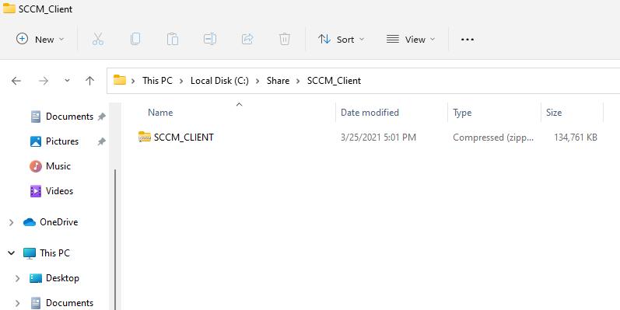

* + 1. Right click on 'SCCM_CLIENT.zip' Folder and extract the Zip.

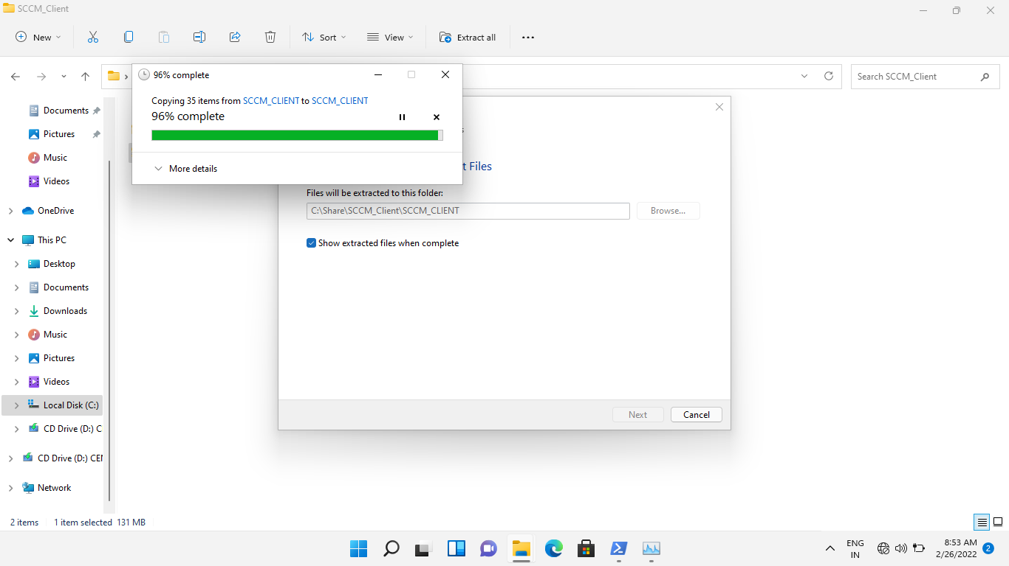

* + 1. Open 'SCCM_Client' Folder.

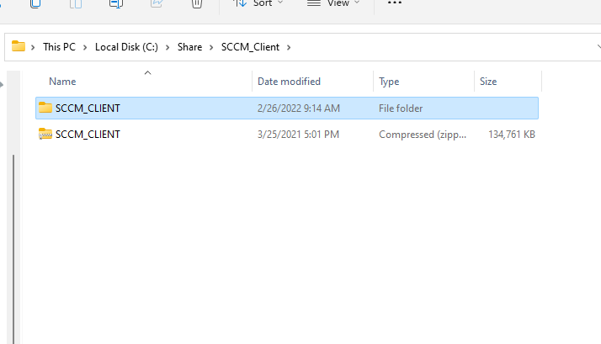

* + 1. Double click on 'ccmsetup.exe' and wait for installation.  
       Note: - User have administrator rights to install the software.

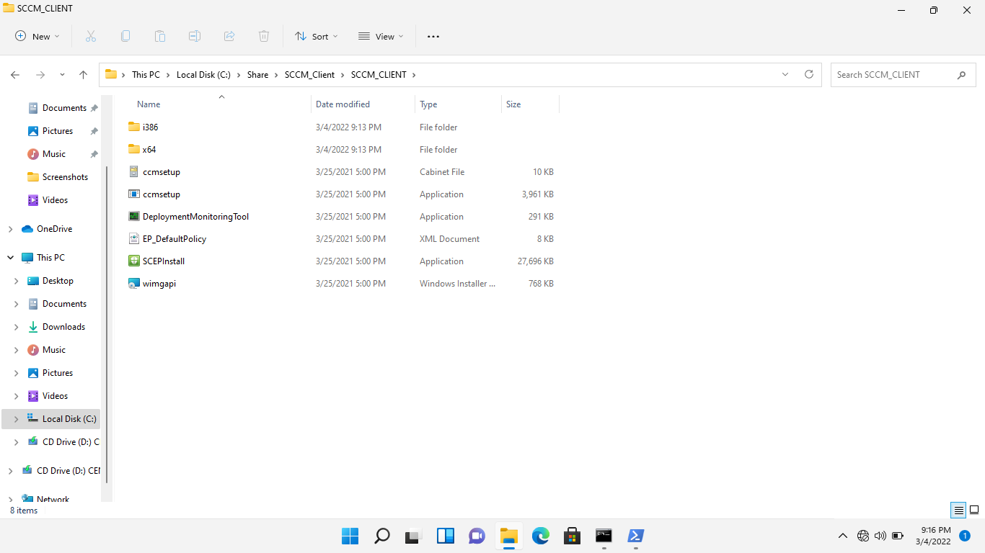

* + 1. Now the installation process is started.

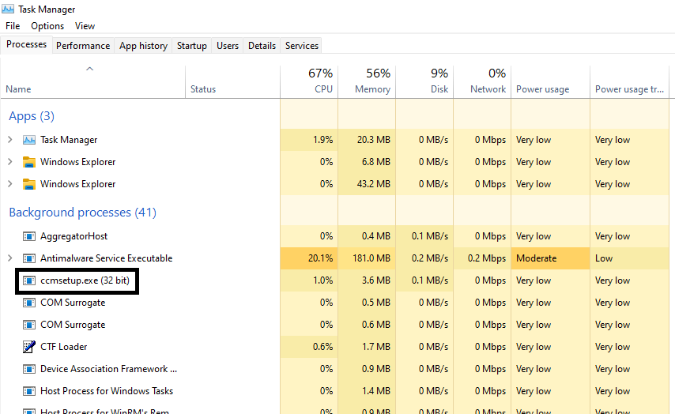

## **Verification:**

* Log in to the machine where SCCM CLIENT is Installed.
* Open “Control Panel”.
* ' Configuration Manager' must be present into the control panel.

